MicroGoal
Ideation Phase
Brainstorm & Idea Prioritization

Date | 5 March 2026
Team ID | SWTID-2026-5680
Project Name | MicroGoal
Maximum Marks | 4 Marks

Brainstorm & Idea Prioritization Template
Step-1: Team Gathering, Collaboration and Select the Problem Statement:-
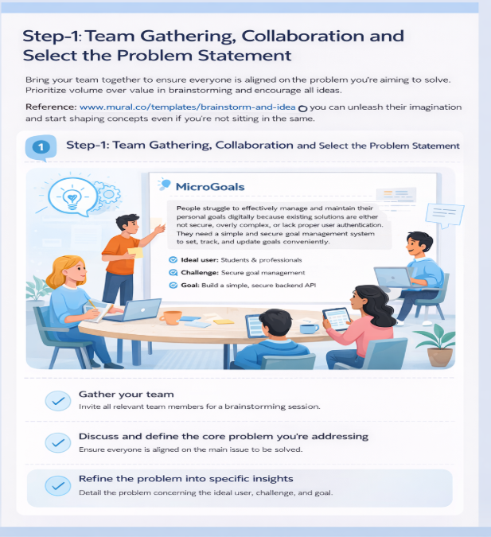
Step-2: Brainstorm, Idea Listing and Grouping:- 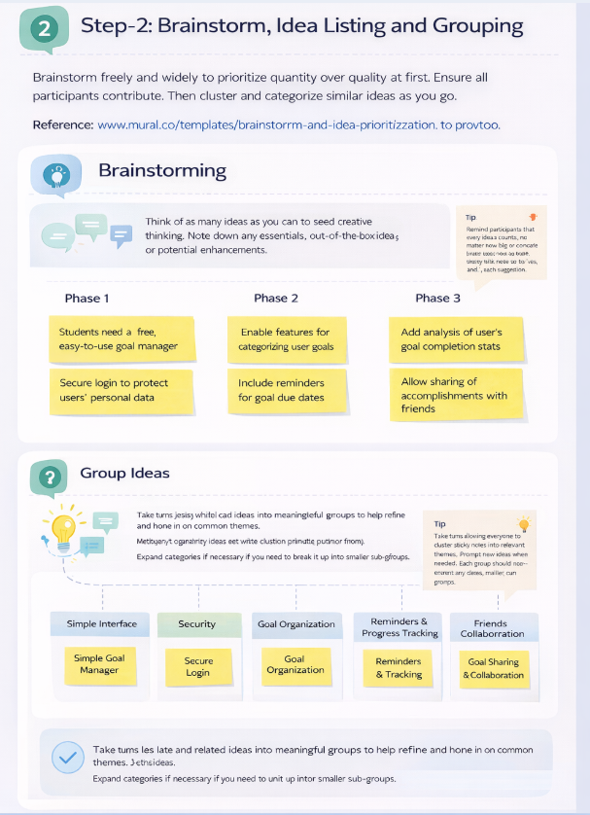

Step-3: Idea Prioritization:- 